
a
Company
Logotype

Cone Beam Computed Tomography- Report



Porur Dental X-rays & CBCT

Patient Name : Mr. Sivasamy | Date of Report : 28.10.2025
Age/ Gender : 45 years/ Male | Region of Interest : CBCT Maxilla
Referring doctor: Dr. Aruleena | Indication : Fracture Alveolus ?
Clinical Notes: Nil
PATIENT INFORMATION

CBCT- Maxilla provided
CBCT – IMAGE DETAILS

RADIOGRAPHIC INTERPRETATION

- In relation to 21 and 22, complete loss of crown is evident, however, the apical third of 11 and 21 are present within the alveolar bone.
- Root stump: 28
- The tooth 18 appears horizontally placed within the alveolar bone with its crown facing posteriorly.
- The maxillary alveolar ridge is present with normal trabecular pattern.
- In relation to 27, presence of distocoronal hypodensity involving the crown, approximating the pulp is evident.

RADIOGRAPHIC IMPRESSION

- Partially edentulous region: 11
- Fractured and retained root portion: 11, 21
- Impacted: 18
- Dental caries: 27
- Root stump: 28

Kindly correlate with clinical findings


IMAGES FOR REFERENCE

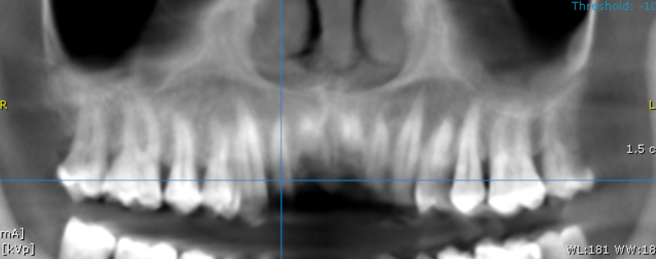

3-DIMENSIONAL VIEW

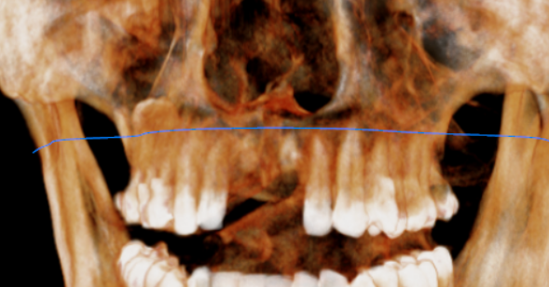

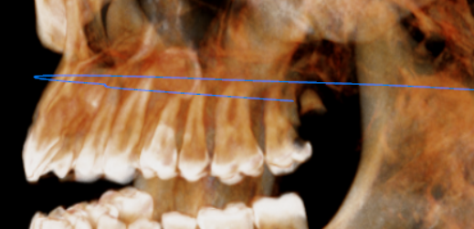
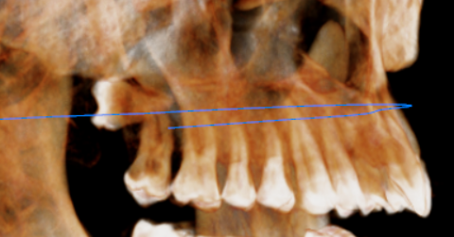
CROSS SECTIONAL VIEW

11 region | 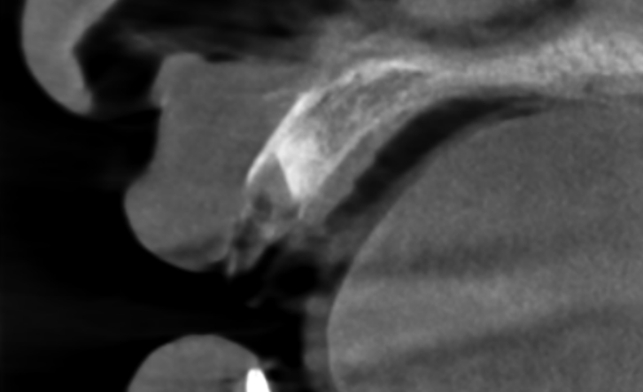
21 region | 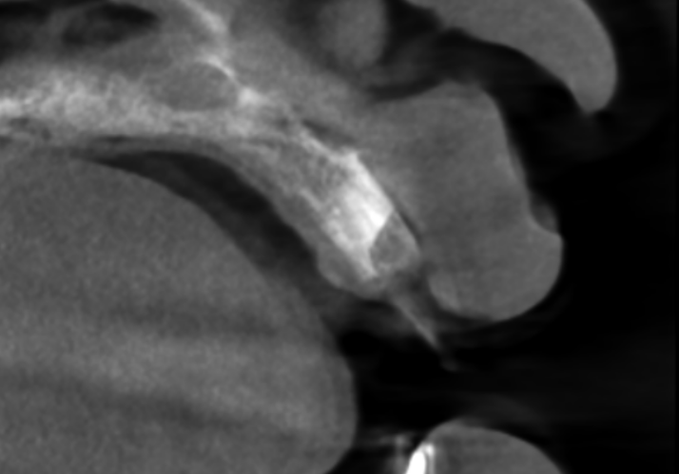

**** End of report ****

